Microsoft Teams Live Event – Presenter view

1. **Join your meeting**

* In Microsoft Teams click on **Calendar** and then click on the **meeting invite** and click **Join**.

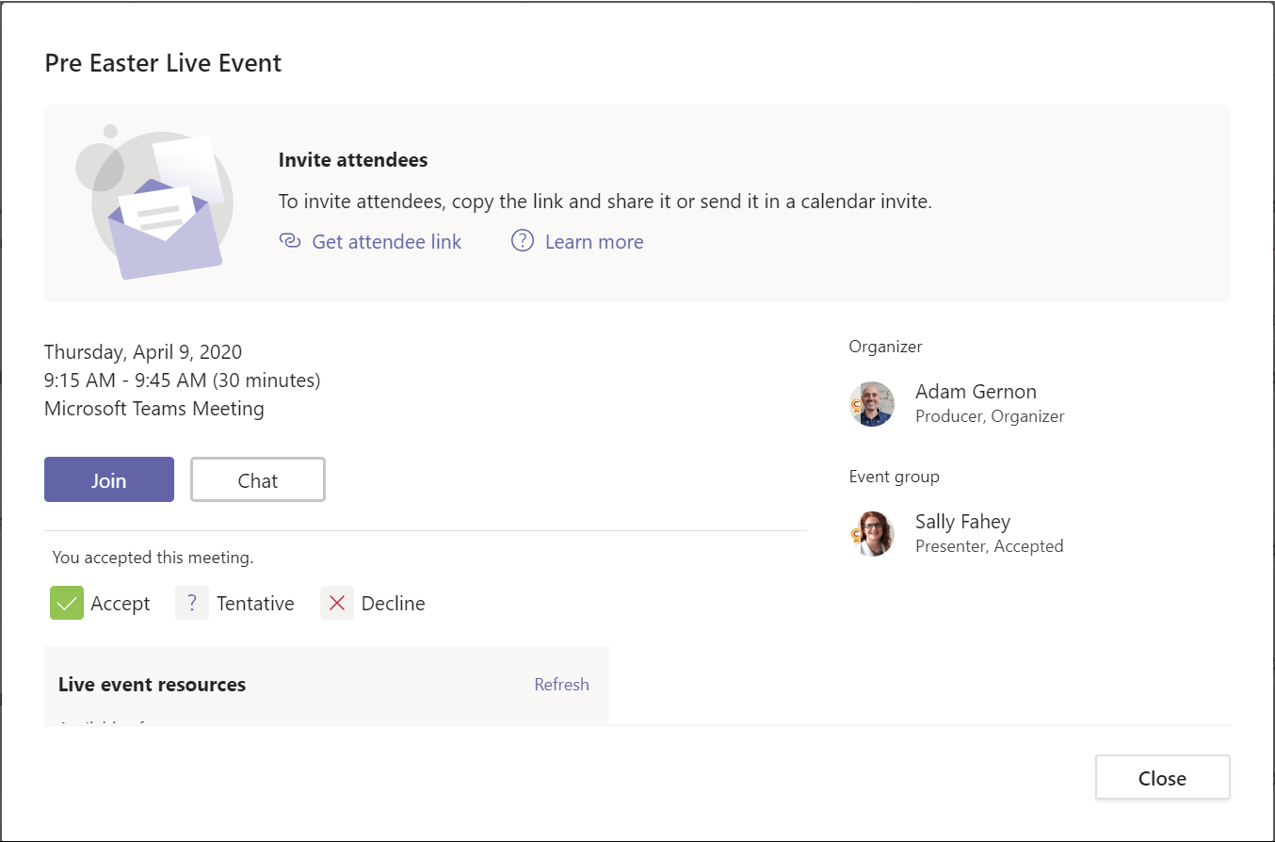

* After clicking on Join, check your settings in the lobby view (video/microphone settings, device selection - which microphone and speaker you will enter the call using). Click **Join**.

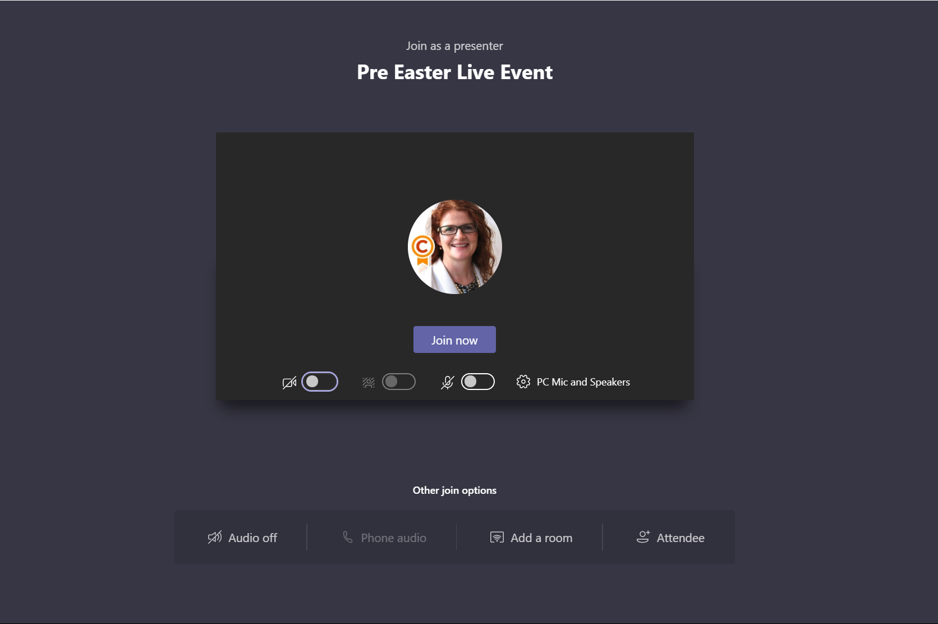

1. **Once you’re in your meeting**

* As a presenter, the window looks very similar to that of a regular Teams meeting: except you now have an indicator to tell you what phase of the event you are in (pre-live or Live), and you have an additional Q&A button. The Chat button allows you to chat with the production crew for the event (producer and other presenters).

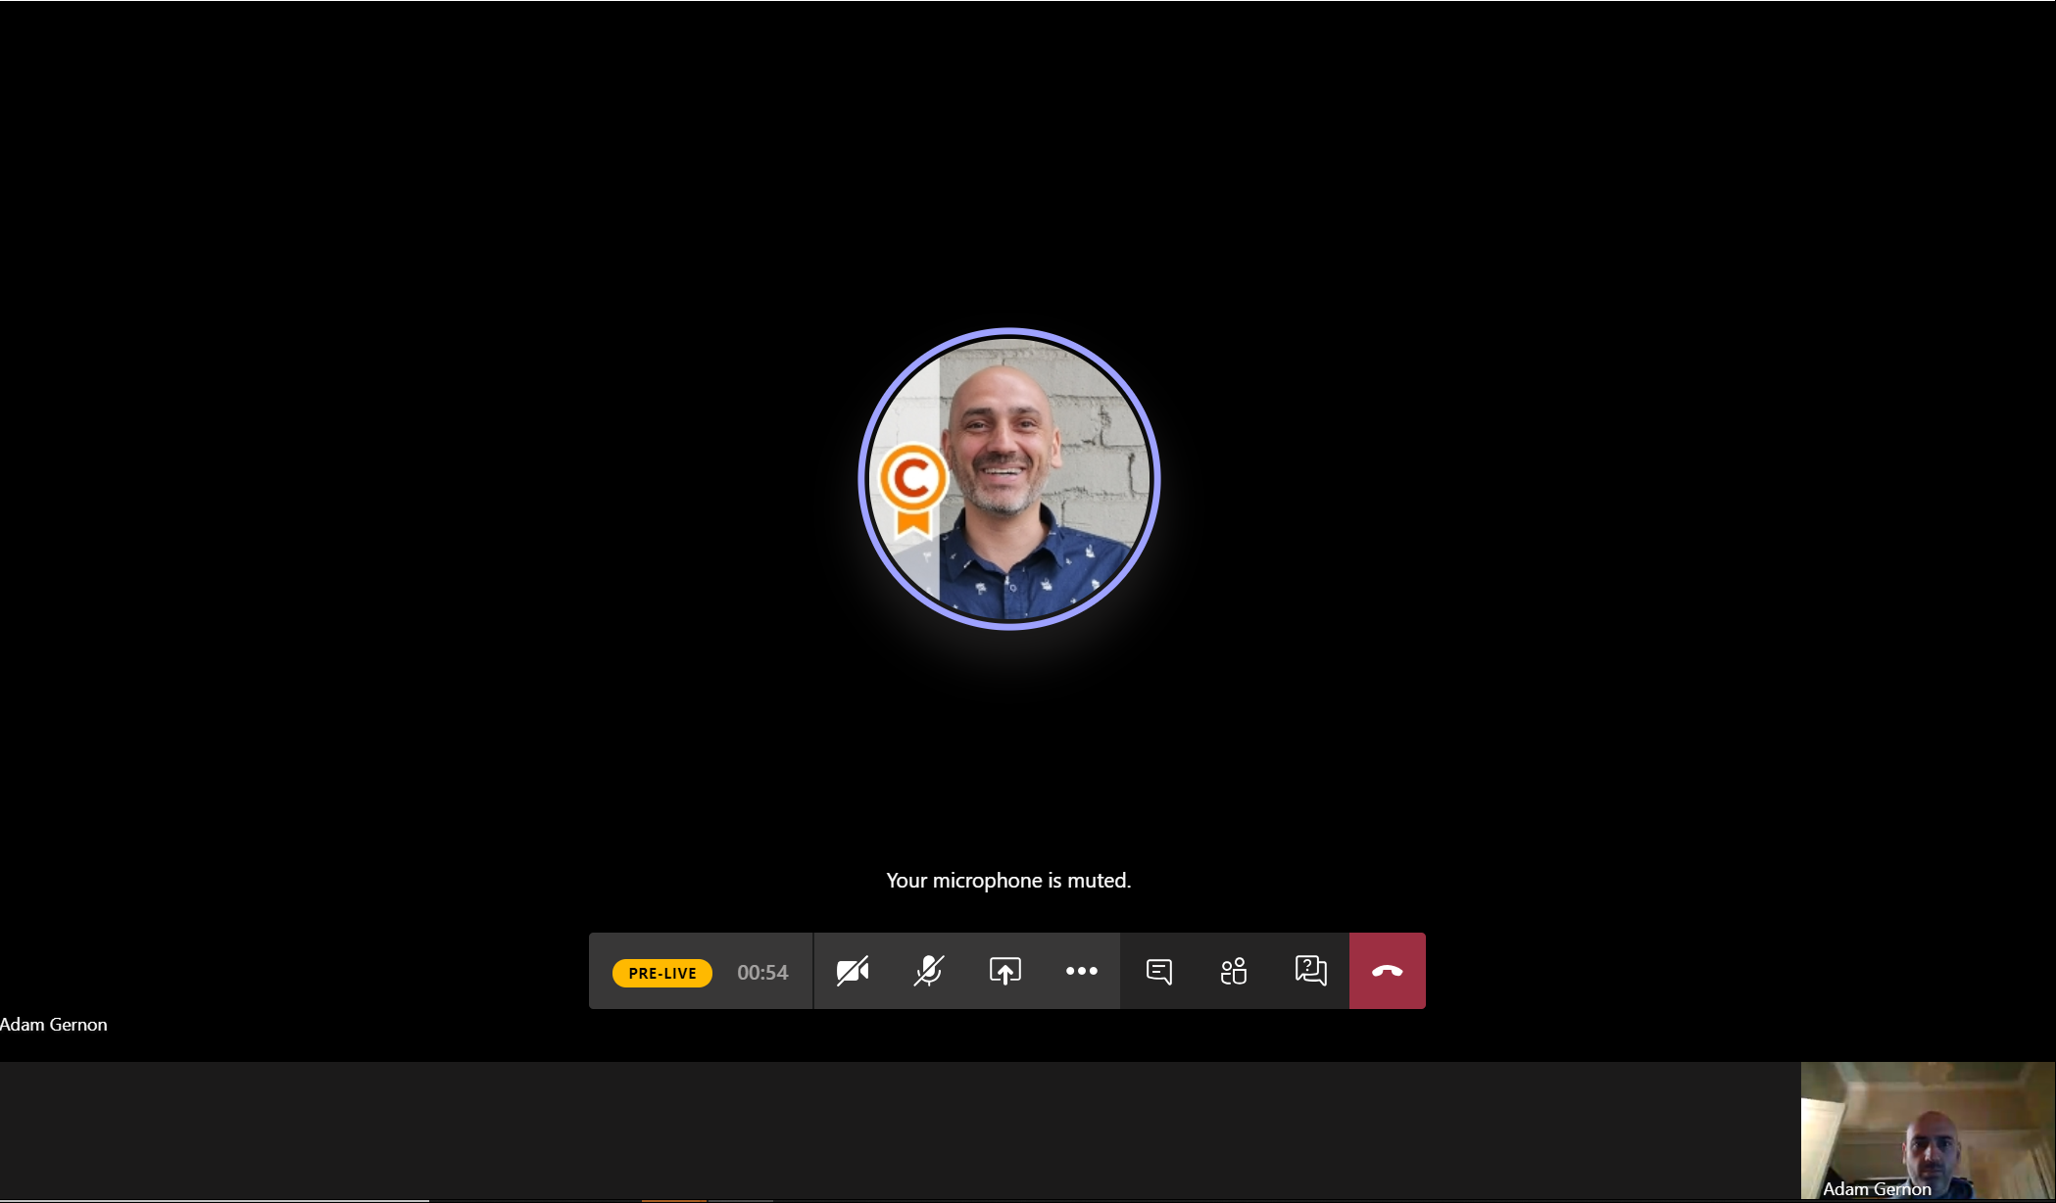

* Once your event goes Live, you will see the event indicator change from a yellow pre-live status to red Live status. You can also see the others in the production crew, and the panel at the bottom of your screen will indicate which feed is live to the audience by framing with a red box and a Live button overlay.

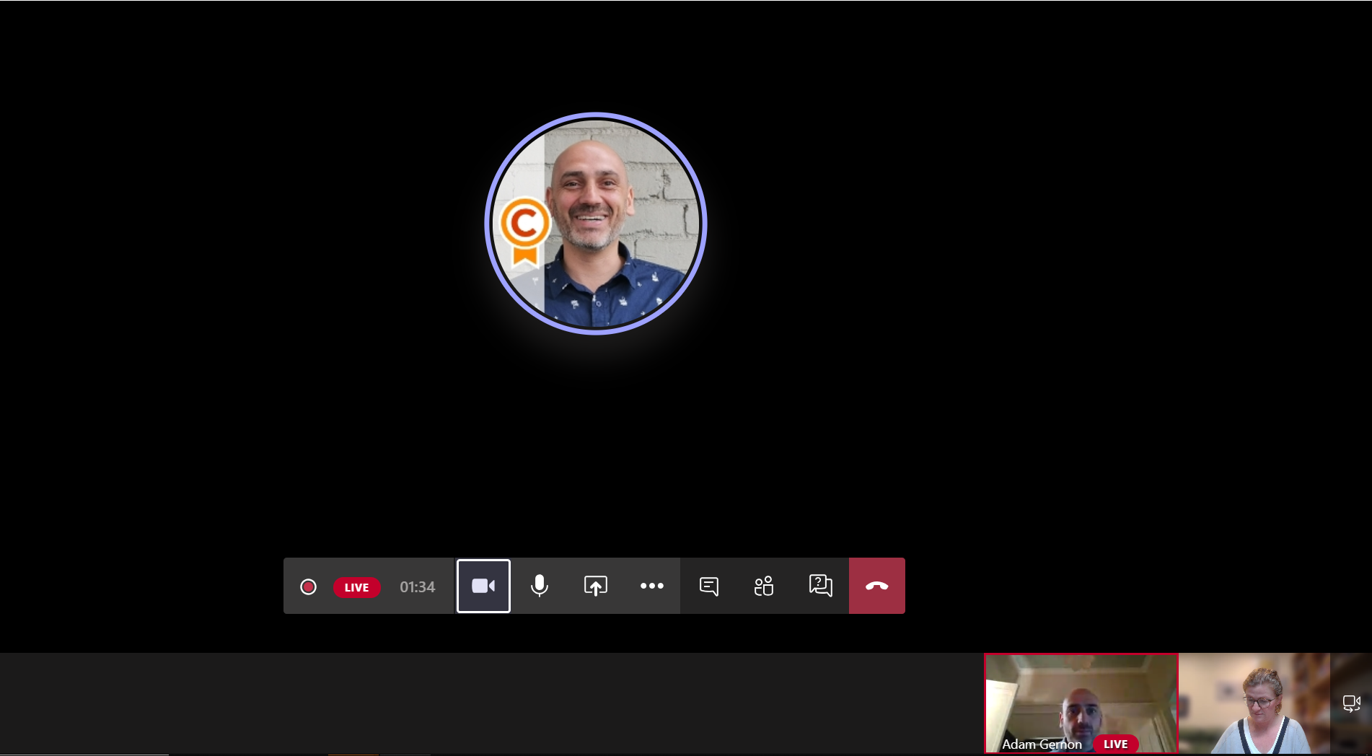

1. **Share content as a presenter**

* As a Presenter, you can use the share button  to select content to share in your event.

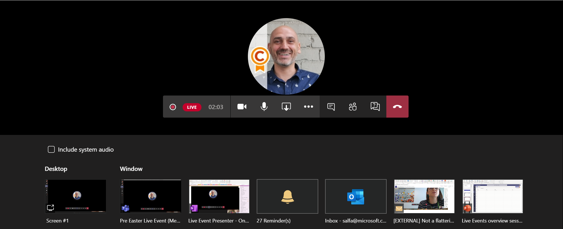

* When you are sharing content, you will see that content on your. Below is *an example* showing a PowerPoint presentation in presenter mode. As the Presenter in a Live Event, you also see the small picture in window of the producer/last presenter. You can minimise this if you like.
* The Teams control bar at the top of your window allows you to stop presenting your content when you choose to.

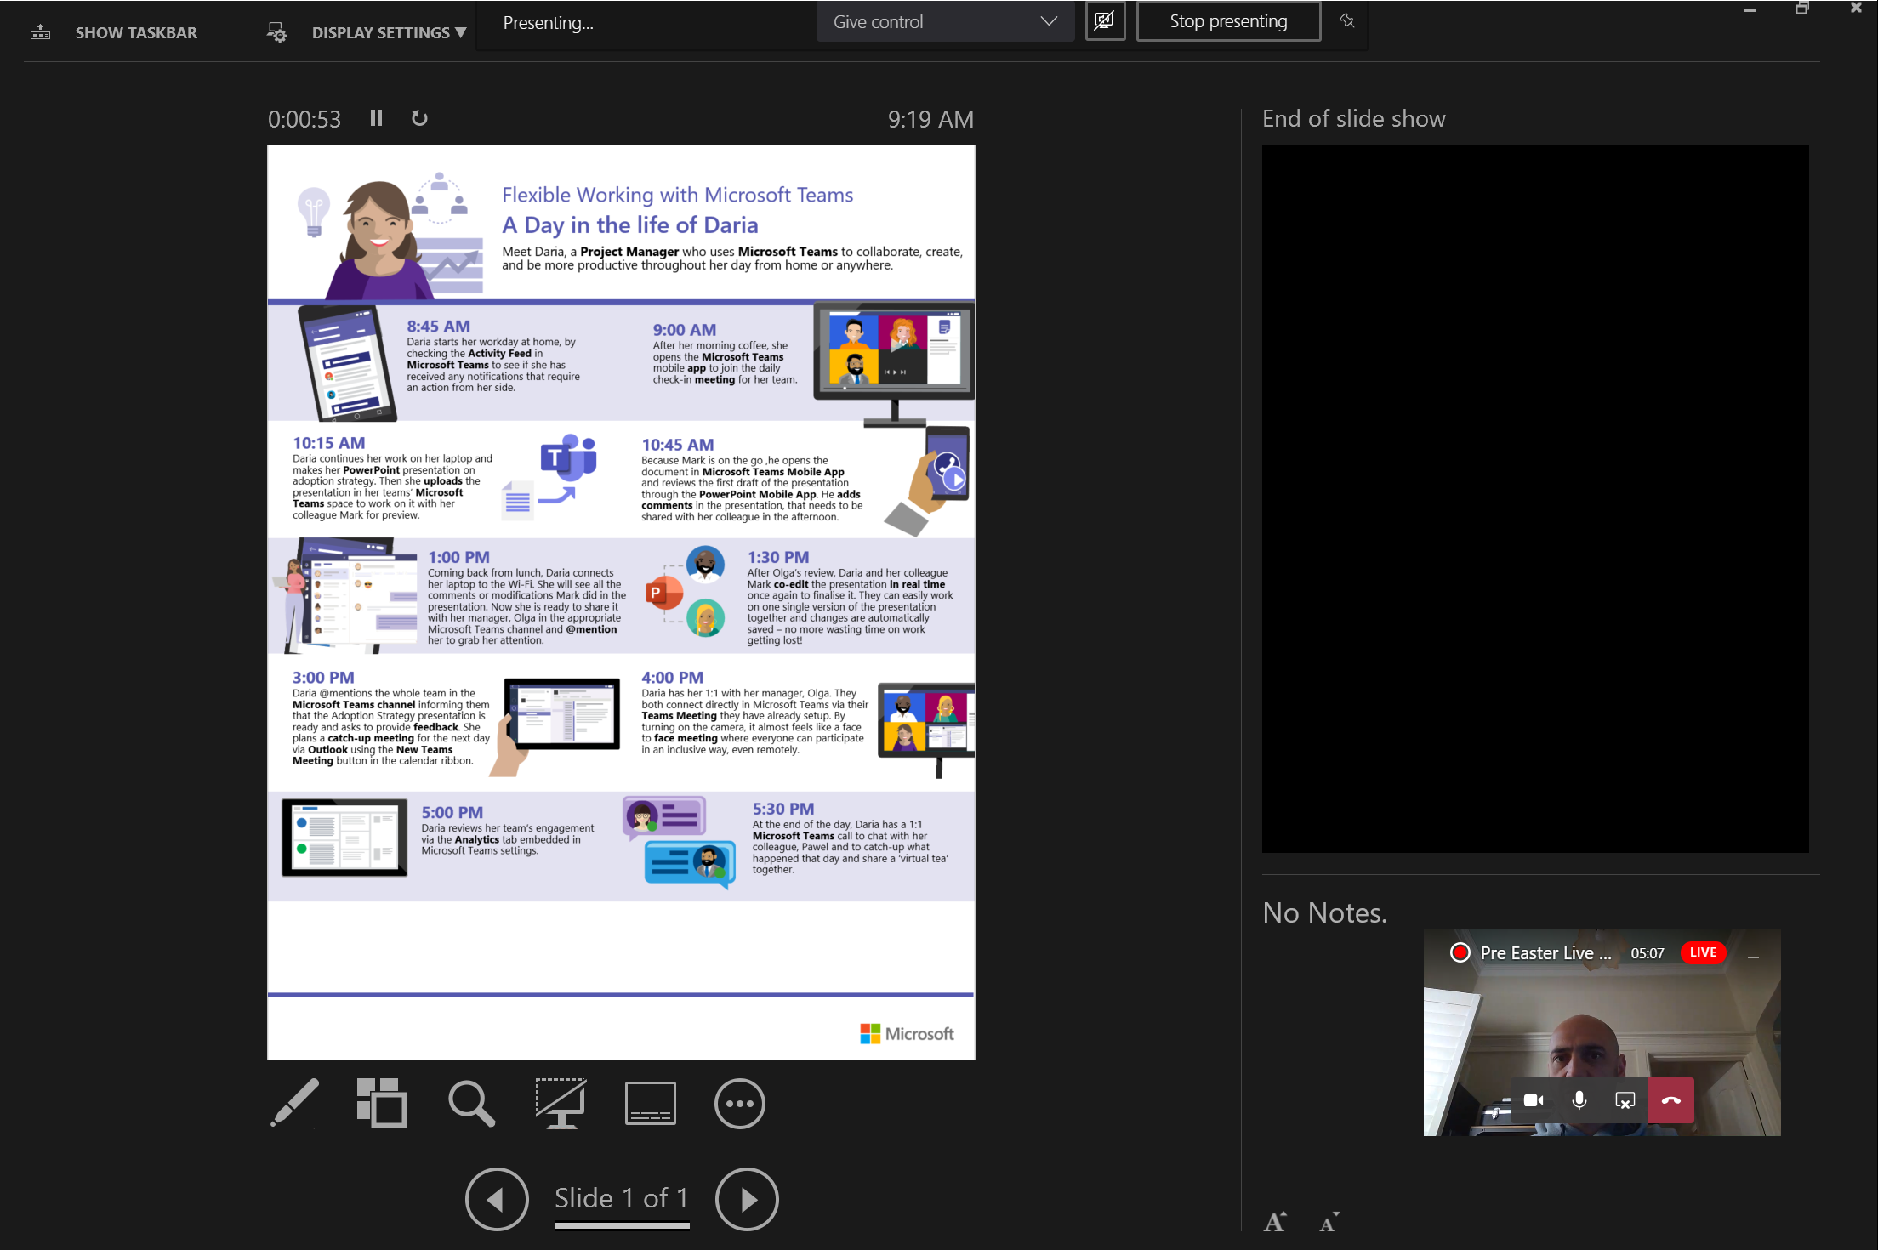

* When you start to present content and there is already something being shared in the event, you will receive the following message:

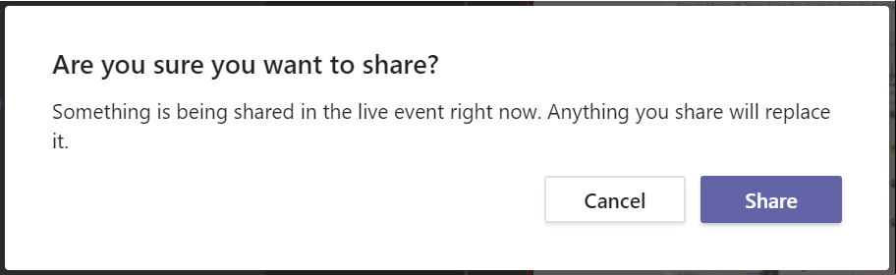

1. **Respond to Q&A as a presenter**

* As a Presenter you can make announcements to the audience and reply to their questions using the Q&A interface, while other presenters are talking. Click on the Q&A button  to expand the control panel:

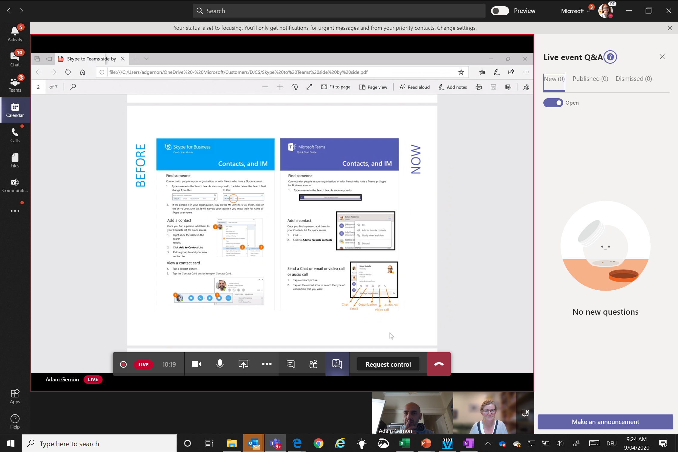

* Questions can be replied to privately, or published for all participants to see.